Batch Comandos

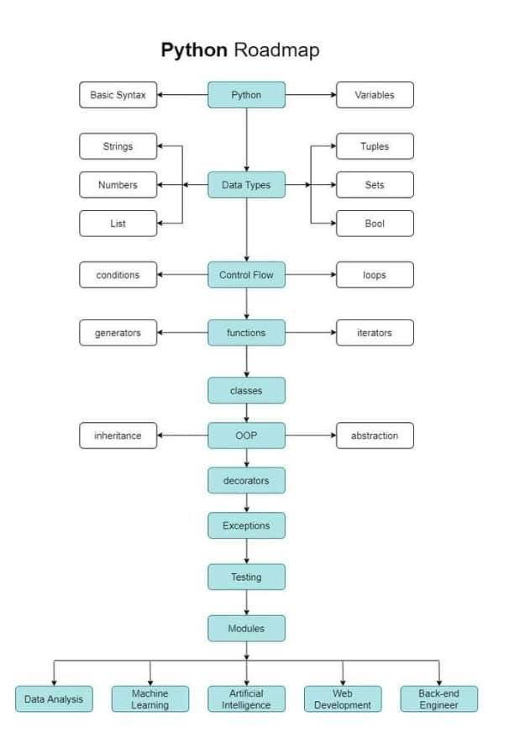

| Decription | Command |
| --- | --- |
| [Desfragmentar Disco](https://www.windows-commandline.com/run-command-disk-defragmenter/) | dfrgui |
| [Descobrir Arquitetura](https://www.windows-commandline.com/check-windows-32-bit-64-bit-command-line/) | wmic os get OSArchitecture  output  64-bit |
| Repair Windows | [sfc /scannow](https://www.ubackup.com/windows-11/repair-windows-11-command-prompt-8523.html) |
|  |  |

# [Date - How to get date / time in batch file](https://www.windows-commandline.com/get-date-time-batch-file/)

# [Comment](https://www.tutorialspoint.com/batch_script/batch_script_comments.htm)

Syntax

:: Remarks

Variáveis

@echo off

set /p nome=Informe o nome ou IP do destino:

echo O nome escolhido foi '%nome%'.

ping.exe %nome%

# Repair Windows

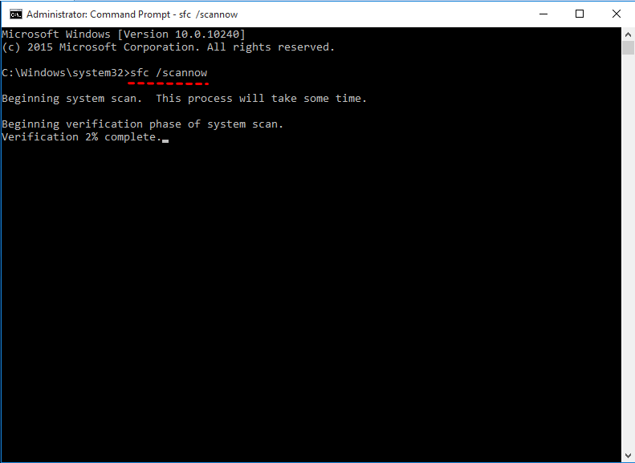

# [Automate .BAT files with Task Scheduler&nbsp;](https://hostman.com/tutorials/how-to-create-and-use-batch-files/)

# Referências para Continuação dos Estudos

[1] WINDOWS-COMMANDLINKE. **How to check if Windows 32 or 64 bit?** Disponível em <<https://www.windows-commandline.com/check-windows-32-bit-64-bit-command-line/>>. Acessado em 05/04/2021.